1. Introduction 1
2. Explanation of the Trading experiment 2
3. Detailed explanation regarding trading 4
3.1 Trading for Producers 4
3.2.1 Production Overview 5
3.2 Detailed explanation regarding trading for retailers 8
3.2.1 Earnings Overview in Stage 2 8
3.2.2 Earnings Overview in Stage 1 12
5 Making an offer 13
6 Offers Overview and Graph 13
6.1 Offers Overview 13
6.2 Offers and Transactions Graph 15
7 Determination of the UNITS DEMANDED for Retailers 16

INSTRUCTIONS

Welcome to the experiment! Please turn off your mobile phone NOW and do not turn it on until you are being told to do so. [Experimenter, please enforce.]

1. Introduction
You are about to participate in an economics experiment. If you follow the instructions carefully, you can earn a substantial amount of money. Your earnings will be paid to you in cash at the end of the experiment.

Your expected earnings are about CZK 500 (including a show up fee of CZK 100) for a session of two hours. Your specific earnings will depend on your choices and the choices of the participants you will be paired with.

General rules

If you have a question, raise your hand and one of the experimenters will come to your desk to answer it.

You are not allowed to communicate with other participants during the experiment. If you violate this rule, you will be asked to leave the experiment and will not be paid (not even your show-up fee).

Your show-up fee of CKZ 100 will be your start capital for the experiment. It is possible to make losses and even to go bankrupt when making poorly thought-through decisions. If you go bankrupt you will be asked to leave the experiment. Please note that there are strategies that, if used, guarantee that you will not go bankrupt and, instead, make profits.

You are allowed to write and make notes on these instructions, or on the blank piece of paper provided.

The experiment exists of five parts, as listed in Table 1 below.

Table 1
- Instructions
- Distribution information
- Comprehension test
- Trading experiment
- Questionnaire

We are now in part 1, "Instructions", where we describe the rules for part 4, the "Trading experiment". In part 2, "Distribution information", we will give you information regarding the distribution of the UNITS DEMANED on the computer screen. In part 3, "Comprehension test", we will test your understanding of the instructions on the computer. In part 4, "Trading experiment", you make choices in the experiment. In part 5, "Questionnaire", we ask you a few questions on the computer.

2. Explanation of the Trading experiment
You will be a member of a group. Including you, there will be «total_no» participants in it. Group membership is assigned randomly. You will not know who is in the group with you and none of your group members will know that you are in his or her group. Group membership, in other words, is anonymous. You will not interact with members of other groups. Your group membership stays fixed for the experiment.

In this experiment, you will make decisions in a market. There will be 20 rounds in total. One of the rounds will be drawn at random and you will be paid the earnings for that round.

In each round there will be two stages, STAGE 1 and STAGE 2.

Figure 1 shows in detail how each round will transpire; please study this figure now before we proceed.: [Experimenter, please enforce.]

Figure 1: Rounds and stages in this experiment
c
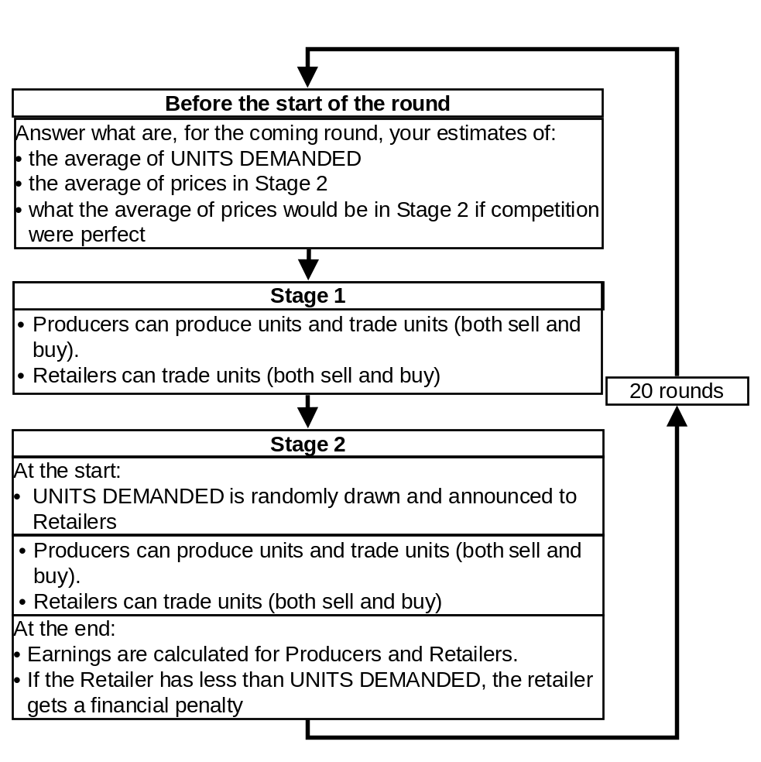

Before each round starts, you are asked to answer three questions. A screen as in Figure 2 will be projected on top of your screen. Please answer the questions as well as you can and within 60 seconds.

Figure 2: Questions before the start of the round
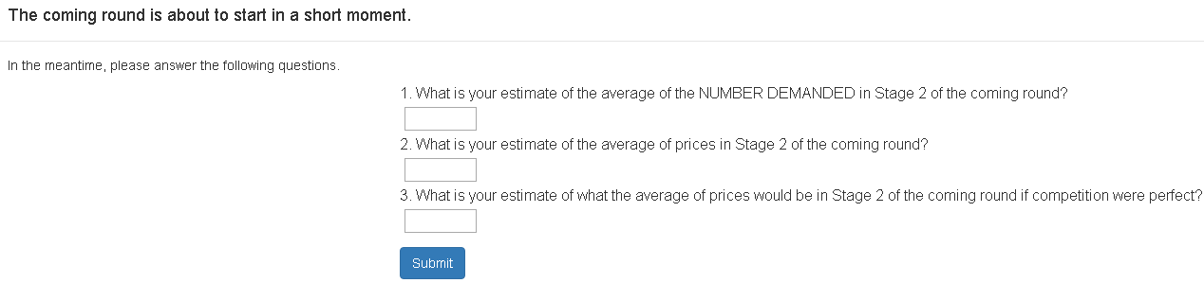

Four group members will be producers of a commodity and four will be retailers. Each round the number of units demanded of a Retailer is drawn at random from a distribution with an average of «ud_average» and a standard deviation of «ud_sd» and we refer to this number of units as "UNITS DEMANDED". Retailers are shown UNITS DEMANDED at the start of Stage 2. Thus, UNITS DEMANDED will be known during Stage 2, but not during Stage 1.

Producers can produce units at a cost and sell these units. Producers may trade: they may not only sell, but also buy units. At the end of the round, the Producer will be credited the net trading revenues minus the cost of production as calculated over Stage 1 and Stage 2.

Retailers can get units by buying them. Retailers may trade: they may not only buy, but also sell units. At the end of Stage 2, the retailer must hold a total of units equal to UNITS DEMANDED. The Retailer will be credited the net trading revenues as calculated over Stage 1 and Stage 2 plus an amount of ECU «rr_average» for each unit he or she holds up to UNITS DEMANDED minus a financial penalty in case the Retailer has less units than UNITS DEMANDED.

Thus, UNITS DEMANDED is the maximum number of units for which the Retailer receives ECU «rr_average». Retailers receives no credits for the units in excess of UNITS DEMANDED.

If, at the end of Stage 2, Retailers have less units than UNITS DEMANDED, they receive a penalty. We define the term "YourMissingUnits" as UNITS DEMANDED minus the number of units the Retailer has. We also define the term "AggregateMissingUnits" as UNITS DEMANDED for all retailers together minus the number of units all retailers together have. The financial penalty for a retailer is calculated as “YourMissingUnits” times the average cost of producing the “AggregateMissingUnits” times two:

The penalty, AverageCostOfAggregateMissingUnits, is calculated as follows. At the end of the round, the aggregate total of missing units over all retailers in the group is calculated. Then it is calculated what is the lowest total cost for which the Producers in your group could produce this number of units. This cost is then divided by the number of units to obtain the AverageCostOfAggregateMissingUnits.

The financial penalty for Retailers may thus be considerable, but can be avoided by obtaining a number of units equal to the number of UNITS DEMANDED as announced at the start of Stage 2.

3. Detailed explanation regarding trading
We will now further explain the information on your screen, first for Producers, and then for Retailers.

3.1 Trading for Producers

Figure 3 shows the screen for Producers

Figure 3: the trading screen for Producers in stage 1 and 2

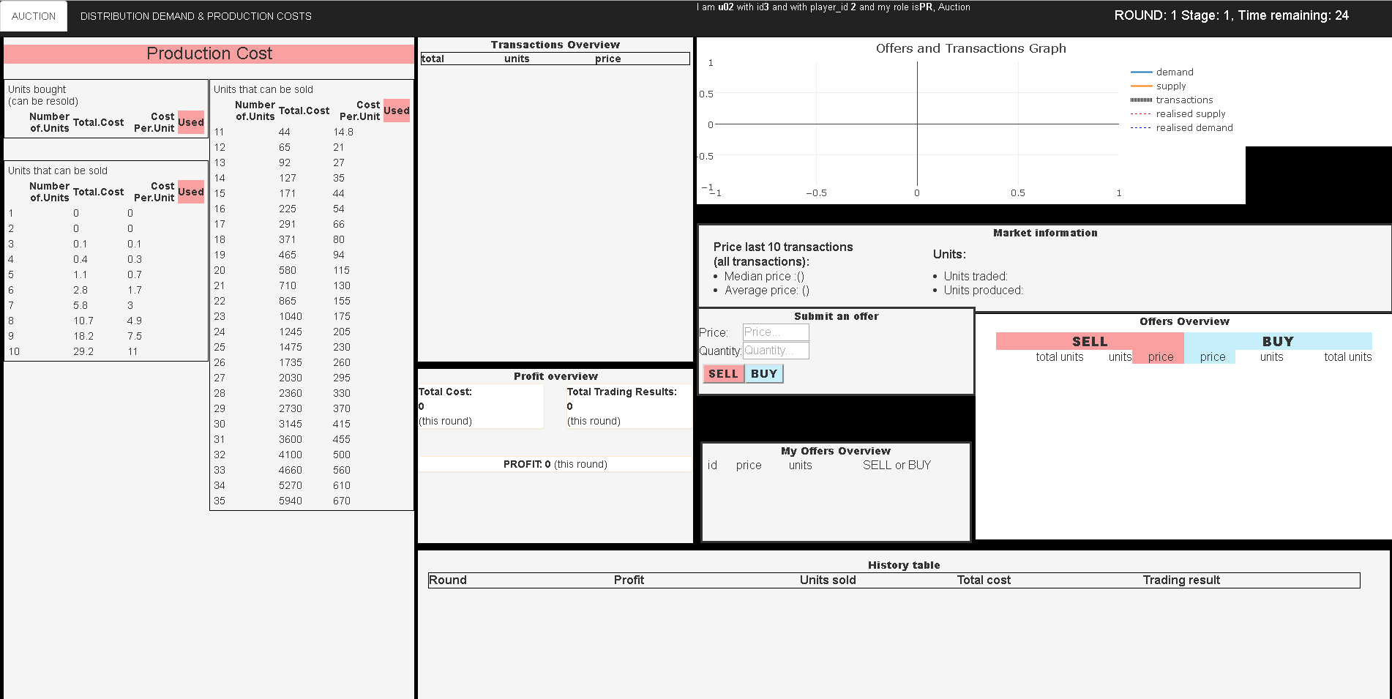

The screen for the Producer is basically the same in Stage 1 and Stage 2. The screen shows the costs of production in the left column, labeled “Production Cost”.

3.2.1 Production Overview

Figure 4: The production cost
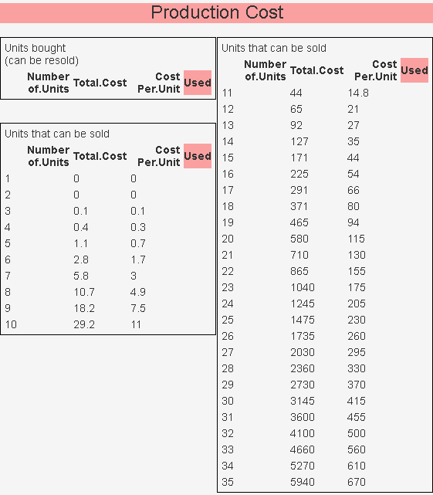

Figure 4 shows a close-up of the Production Overview for the Producer. The units are numbered in the first column labeled "Number of units". The column labeled "Total Cost" indicates the total costs to produce and sell the Number of units. The column labeled "Cost per Unit" shows the cost of each unit. As you can see, selling the first two units costs zero, the 3rd units costs 0.1, the 4th unit 0.3, and so on.

Please make sure that you understand this. If you do not, raise your hand.

Figure 5: Production costs for different examples
a) | b) | c)
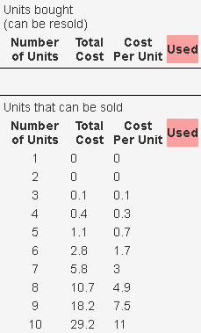 | 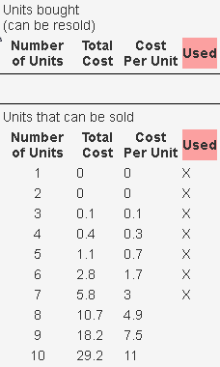 | 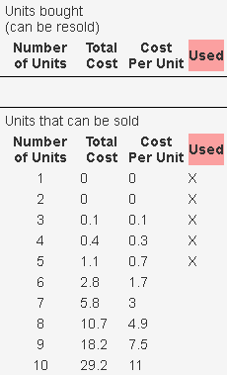
 | - Sold 7 units | - Sold 7 units  - Bought 2 units  Net: sold 5 units (7–2)
c) | d) | e)
 | 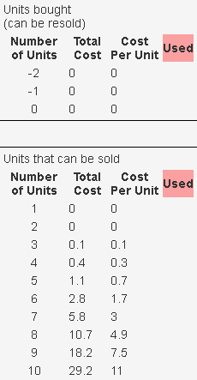 | 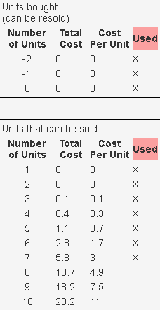
- Sold 7 units  - Bought 2 units  Net: sold 5 units (7–2) | - Sold 7 units  - Bought 2 units  - Bought 8 units  Net: sold–3 units (7–2–8) | - Sold 7 units  - Bought 2 units  - Bought 8 units  - Sold 10 units  Net: sold 7 units (7–2–8+10)

As soon as the Producer sells units, the sold units are ticked off with a cross in the column “Used”. Figure 5 gives an example to show how the selling and buying of units is accounted and visualized on your screen.

Figure 5.a: The Producer has not sold anything yet.
At the start of a round, if the producer hasn’t sold anything yet, all units are unused (none of the units has been marked with a cross in the column "Used").

Figure 5.b: The Producer has sold 7 units.
When the Producer in Figure 5a sells 7 units, the Producer uses the first seven units that are not used, which are in this example the units with Number 1 to 7. As can be seen in the column “Total.Cost”, the Producer incurs a total production cost of 3 by using these 7 units. After selling these units are marked with a cross in the column "Used" to indicate that they cannot be used anymore. The column now looks as in Figure 5.c. As you can see, the Producer has now incurred a Total.Cost of 5.8 ECU.

If the Producer would now like to sell one more unit, the cost of using the unit is indicated by the Cost.Per.Unit of the first unused unit, which is in this example unit Number 8 with a Cost.Per.Unit of 4.9.

Please make sure that you understand this. If you do not, raise your hand.

Figure 5.c: The producer has sold 7 units, and then bought 2 units.
A producer may also buy units. Buying reverts used units to unused ones. Thus, if the Producer in the example in Figure 5.b buys 2 units, the units Number 6 and 7 are becoming unused and their cross marks disappear. Units Number 6 and 7 can be used again and the column looks as in Figure 5.c. As Units Number 6 and 7 are not used anymore, they no longer contribute to the Total.Cost. You can see that, as a result, the Total.Cost has been lowered to a total of 1.1 ECU.

Figure 5.d: The producer has sold 7 units, then bought 2 units, and then bought another 8 units.
If the Producer in Figure 5.c buys another 8 units, (s)he will have bought in total more units (10) than (s)he had sold (7). This results in a “negative” Number of units, namely -3. We can see the three “negative” units as “stockpiling” by the Producer. At a later stage the Producer can sell the 3 units without incurring extra costs.

In Figure 5.d we see that buying the 8 units reverts units Numer 1 to 5 to unused and in addition obtains three extra units that have a zero (0 ECU) Cost.Per.Unit. These units are shown in the upper box with a Number smaller than 1, as shown in Figure 5.d You can see that, as a result, the Total.Cost has been lowered to a total of 0 ECU.

Figure 5.e: The producer has sold 7 units, then bought 2 units, then bought another 8 units and then sold 10 units.
If the Producer in Figure 5.d now sells again 10 units, 10 units are used and are marked with a cross in the column "Used", starting with the unused one with the lowest Number. Thus, units from Number -2 till 7 are used, as shown in Figure 5.e. You can see that, as a result, the Total.Cost has been increased back to a total of 5.8 ECU.

Please make sure that you understand this. If you do not, raise your hand.

Transaction Overview
At the top, to the right of the Production Overview, is the Transaction Overview. In this overview, each line represents a transactions. Sales always have a positive number of units and purchases a negative number. Thus, the Trading account of the Producer in the example in Figure 5.e would look as in Figure 6. You can see that the last transaction was selling 10 units for a price per unit of 4, before that buying 8 units for a price per unit of 3, and so on.

Figure 6: Transaction overview for a specific example
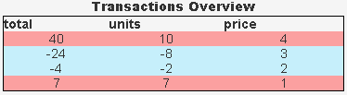

Profit Overview
Under the Transaction Overview is the Profit Overview. It shows the Total Cost, the Total Trading Results, and the PROFIT. For the Producer in the example, the Profit Overview looks as in Figure 7.

Figure 7: Profit overview for a specific example
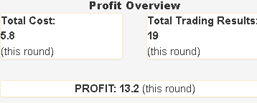

3.2 Detailed explanation regarding trading for retailers

The retailer sees a screen as in Figure 8.

Figure 8: the trading screen for retailers in stage 2
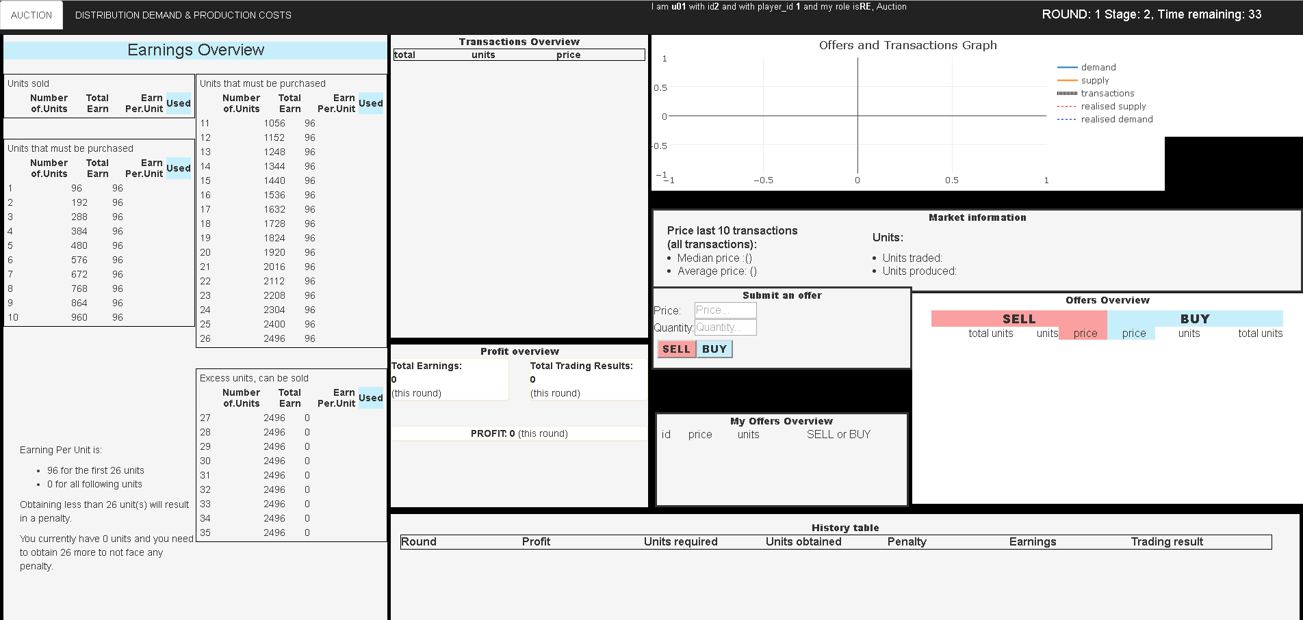

The screen for the Retailer is somewhat different in Stage 1 and Stage 2. We will first focus on the screen in Stage 2.

3.2.1 Earnings Overview in Stage 2

Figure 9: Earnings overview in stage 2
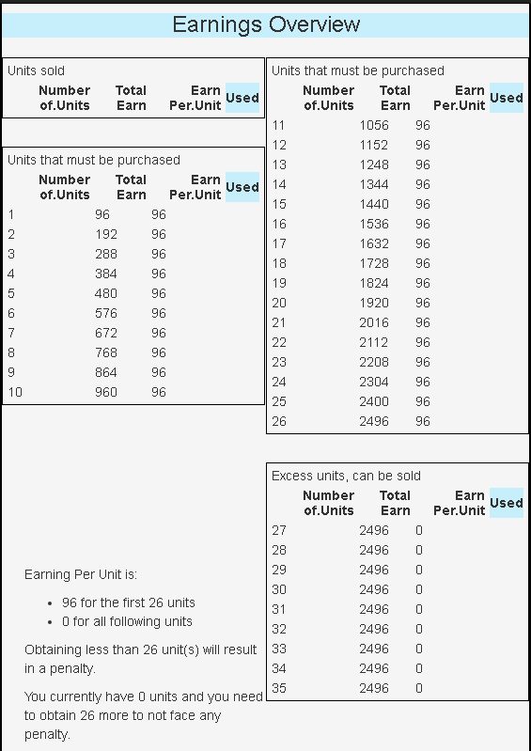

Figure 9 shows a close-up of the Earnings Overview for the Retailer. The units are numbered in the first column labeled "Number of Units". The column labeled "Total Earnings" shows the total earnings for any number of units bought. The column labeled "Earn per.Unit" shows the earning per unit bought. As you can see, for each unit bought, ECU «rr_average» is earned, up to the number of UNITS DEMANDED, which is 26 in the example in Figure 9. Thus using one unit brings «rr_average», using two units a total of 192, using three units a total of 288, and so on.

As can be seen in Figure 9, for any units additional to the number of UNITS DEMANDED, zero (0 ECU) is earned. The number of UNITS DEMANDED is drawn at random from a normal distribution with mean «ud_average» and standard deviation «ud_sd».

Please make sure that you understand this. If you do not, raise your hand.

Figure 10: Earnings overview for different examples
a) | b) | c)
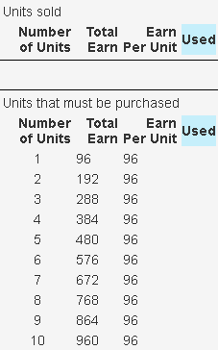 | 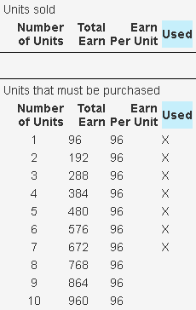 | 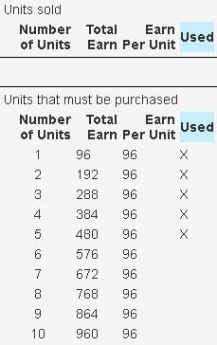
 | - Bought 7 units | - Bought 7 units  - Sold 2 units  Net: bought 5 units (7–2)
c) | d) | e)
 | 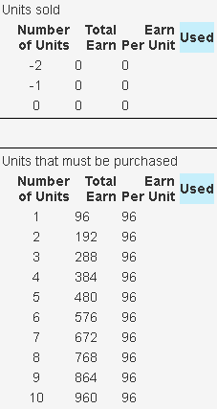 | 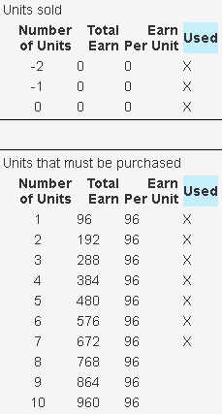
- Bought 7 units  - Sold 2 units  Net: bought 5 units (7–2) | - Bought 7 units  - Sold 2 units  - Sold 8 units  Net: bought –3 units (7–2–8) | - Bought 7 units  - Sold 2 units  - Sold 8 units  - Bought 10 units  Net: bought 7 units (7–2–8+10)

As soon as the Retailer sells units, the sold units are ticked off with a cross in the column “used”. Figure 10 gives an example to show how the selling and buying of units is accounted and visualized on your screen.

Figure 10.a: The Retailer has not bought anything yet.
At the start of a round, if the Retailer hasn’t bought anything yet, all units are unused (none of the units has been marked with a cross in the column "Used").

Figure 10.b: The Retailer has bought 7 units.
When the Retailer in Figure 10.a buys 7 units, the Retailer uses the first seven units that are not used, which are in this example the units with Number 1 to 7. After buying these units are marked with a cross in the column "Used" to indicate that they cannot be used anymore. The column now looks as in Figure 5.b. . As you can see in the column, the Total.Earnings are now 672 ECU.

If the Retailer would now like to buy one more unit, the earnings that the unit brings is indicated by the Earnings.Per.Unit of the first unused unit, which is in this example unit Number 8 with an Earnings.Per.Unit of 96.

Please make sure that you understand this. If you do not, raise your hand.

Figure 10.c: The Retailer has bought 7 units, and then sold 2 units.
A Retailer may also sell units. Selling reverts used units to unused. Thus, if the Retailer in the example in Figure 10.b sells 2 units, the units Number 6 and 7 are becoming unused and their cross marks disappear. Units Number 6 and 7 can be used again and the column looks as in Figure 10.c. As Units Number 6 and 7 are not used anymore, they no longer contribute to the Total.Earnings. You can see that, as a result, the Total.Earnings have been lowered to a total of 480 ECU.

Figure 10.d: The Retailer has bought 7 units, then sold 2 units, and then sold another 8 units.
If the Retailer in Figure 10.c sells another 8 units, (s)he will have sold in total more units (10) than (s)he had bought (7). This results in a “negative” Number of units, namely -3. We can see the three “negative” units as a “loan” by the Retailer. At a later stage the Retailer must buy the 3 units to repay the “loan”.

In Figure 10.d we see that selling the 8 units reverts units Numer 1 to 5 to unused and in addition obtains three extra units that have zero (0 ECU) Earnings.Per.Unit. These units are shown in the upper box with a Number smaller than 1, as shown in Figure 10.d You can see that, as a result, the Total.Earnings have been lowered to a total of 0 ECU.

Figure 10.e: The Retailer has bought 7 units, then sold 2 units, then sold another 8 units and then bought 10 units.
If the Retailer in Figure 10.d now buys again 10 units, 10 units are used and are marked with a cross in the column "Used", starting with the unused one with the lowest Number. Thus, units from Number -2 till 7 are used, as shown in Figure 10.e. You can see in the column that, as a result, the Total.Earnings have been increased back to a total of 672 ECU.

Please make sure that you understand this. If you do not, raise your hand.

Transaction Overview
At the top, to the right of the Earnings Overview is the Transaction Overview. In this overview, each line represents a transactions. Sales always have a positive number of units and purchases a negative number. Thus, the Transaction Overview of the Retailer in the example in Figure 10 would look as in Figure 11 and it can be seen that the last transaction was buying 10 units for a price per unit of 4, before that selling 8 units for a price per unit of 3, and so on.

Figure 11: Transaction overview for a specific example
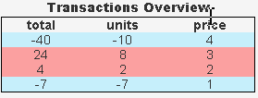

Under the Transaction Overview is the Profit Overview. It shows the Total Costs of production, the Total Trading Results, and the PROFIT. For the Retailer in the example, the Profit Overview looks as in Figure 11.

Profit Overview
Under the Transaction Overview is the Profit Overview. It shows the Total Earnings, Total Trading Results, and the PROFIT. For the Retailer in the example, the Profit Overview looks as in Figure 12.

Figure 12: Profit Overview for a specific example
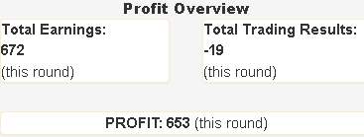

3.2.2 Earnings Overview in Stage 1
For Retailers, the information shown in the tables is somewhat different in Stage 1, because the number of UNITS DEMANDED is not know yet. The earnings are therefore for each unit shown as “?”.

Figure 13: Earnings overview in stage 1
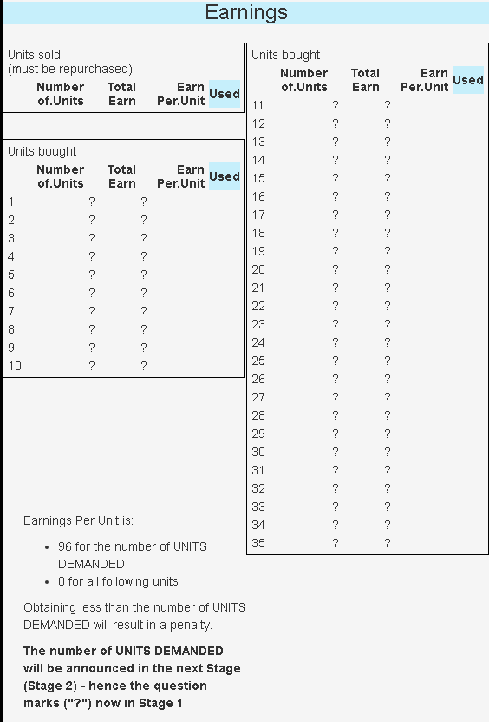

5 Making an offer

Figure 14: making an offer
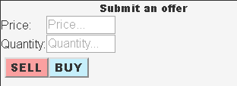
In the box labeled “Submit an offer”, see Figure 14, offers can be made. Fill out the price and the quantity you wish and then press SELL or BUY. After you made an offer, it will become visible in the box below, labeled “My Offers Overview”. See Figure 15 for an example.

Figure 15: My Offers Overview for a specific example
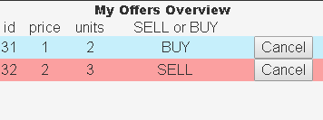

In the example in Figure 15, the participant made both a sell and a buy offer. This is allowed and you will never make a transaction “with yourself” (even if your BUY offer quotes a higher price than your SELL offer, your own orders will never be matched with one another). You cannot have more than one SELL and/or one BUY offer. If you make a second offer of the same type, the previous one is discarded. Note that you can also cancel your standing offer by pressing the Cancel button.

If you make an offer, the program checks if there are matching outstanding offers of other participants.

If you made a SELL offer:
- a match occurs when there are outstanding BUY offers with a price equal or higher than yours (they are willing to pay the price you asked or more).
If you made a BUY offer:
- a match occurs when there are outstanding SELL offer with a price equal or lower than yours (they are willing to sell for the price you are offering or for less).

When there are matches, the program selects the match that has the best price for you (lowest if you made a BUY offer, highest if you made a SELL offer). The program then clears your offer. Your offer is erased and a transaction is registered with the transaction price of the outstanding offer. If the outstanding offer was for less units than the number of units in your offer, your offer is split in a part that is cleared and a part that cannot be cleared by this match. The program then looks if there are other matching offers to clear with. It is thus possible that your offer is cleared with different standing offers for different prices. a part of your offer is cleared immediately and that the remaining part of your offer is shown in the tables.

6 Offers Overview and Graph

6.1 Offers Overview

Figure 16.a
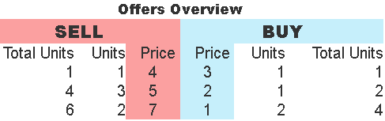

In the box labeled “Offers Overview” you can see the offers. Figure 16.a shows the “Offers Overview” box for a specific example with fictitious offers. The offers are ordered by price, from the best price to the worst price. Offers are thus ordered from low to high for SELL offers and from high to low for BUY offers. The column Units shows the number of Units that are on offer for that price. The column Total Units shows the total number of Units that are on offer at that price or better prices.

Thus, if you want to buy units, you need to look at the SELL offers. As you can see in Figure 16.a, the best (cheapest) SELL offer is in the first row with a Price of 4. Presently, there is just one (1) Unit offered for this price. The next-best SELL offer is in the second row with a Price of 5. There are three (3) Units offered for this price. The worst SELL offer is in the third row with a Price of 7. There are two (2) Units offered for this price.

If you want to sell units, you need to look at the BUY offers. As you can see in Figure 16.a, the best (most expensive) BUY offer is in the first row with a Price of 3. Presently, there is just one (1) Unit offered for this price. The next-best BUY offer is in the second row with a Price of 2. There is one (1) Unit offered for this price. The worst BUY offer is in the third row with a Price of 1. There are two (2) Units available for this price.

Figure 16.b Made a BUY offer of 3 units for a price of 10
 | 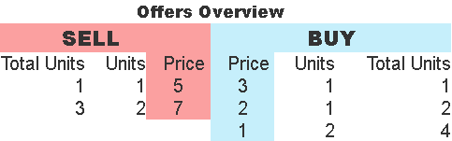
- Before | - After: Made a BUY offer of 3 units for a price of 10

When you make an BUY offer, your offer will be matched to the existing SELL offers if their price is equal to your price or better (better means cheaper for Sell offers). Your offers are executed always for the best price available. Thus, if you would write a new BUY offer of 3 Units for a Price of 10, your BUY offer would first be matched with the SELL offer in the first row. You would thus get 1 Unit for a Price of 4. The remaining two Units in your BUY offer would be matched with the Units in the second row, for a Price of 5. You would thus get 3 Units in total, one for a price of 4 and two for a price of 5.The Offer Overview has now changed, as you fully used the SELL offer in the first row (for a price of 4) and 2 of the 3 units in the second row (for a price of 5). See Figure 16.b.

Figure 16.c Made a BUY offer of 3 units for a price of 2
 | 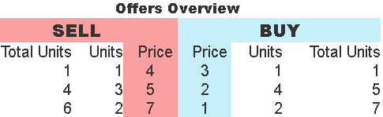
- Before | - After: Made a BUY offer of 3 units for a price of 2
If your offer cannot be matched for all the units, your offer is added to the table. Thus, if you the Offer Overview is as in Figure 16.c, and you make a BUY offer of 5 Units for a Price of 2, it will be added to the BUY units in the second row.

Figure 16.d Made a BUY offer of 11 units for a price of 9
 | 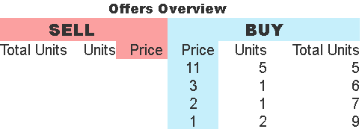
- Before | - After: Made a BUY offer of 11 units for a price of 11
If you make a BUY offer of 11 Units for a Price of 9, you will buy all the outstanding SELL offers. You thus get a total of 6 units, 1 Unit for a Price of 4, 3 Units for a Price of 5 and 2 Units for a Price of 7. As there are still 5 Units left in your offer, they will be added to the BUY offers. See Figure 16.d.

The same logic applies when you make SELL offers.

6.2 Offers and Transactions Graph
All the transactions made and the active offers are also shown in the graph, see Figure 16. All the lines in red show SELL offers, while the lines in blue show BUY offers. The thick black line shows transactions.

Figure 17: Offers and Transactions Graph for a specific example
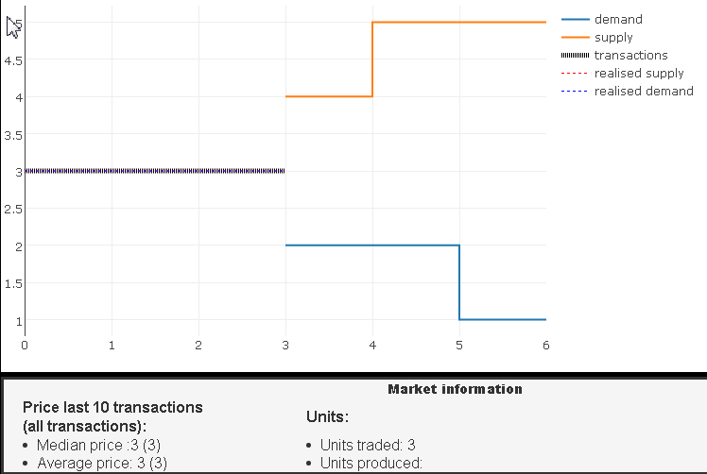

Compare the Offer Overview in Figure 15 with the Offer and Transactions Graph in Figure 17 and verify that the Offer and Transactions Graph shows the same information on the outstanding offers as the Offer Overview.

7 Determination of the UNITS DEMANDED for Retailers
The number of UNITS DEMANDED for the retailer is drawn at random from a distribution with a mean of 60 and a standard deviation of 20.

To help you understand what such a distribution looks like, we show you first the screen “Distribution UNITS DEMANDED and Production cost” has a graphical display of the distribution. The screen looks like Figure 18.

Figure 18: Distribution UNITS DEMANDED and Production cost
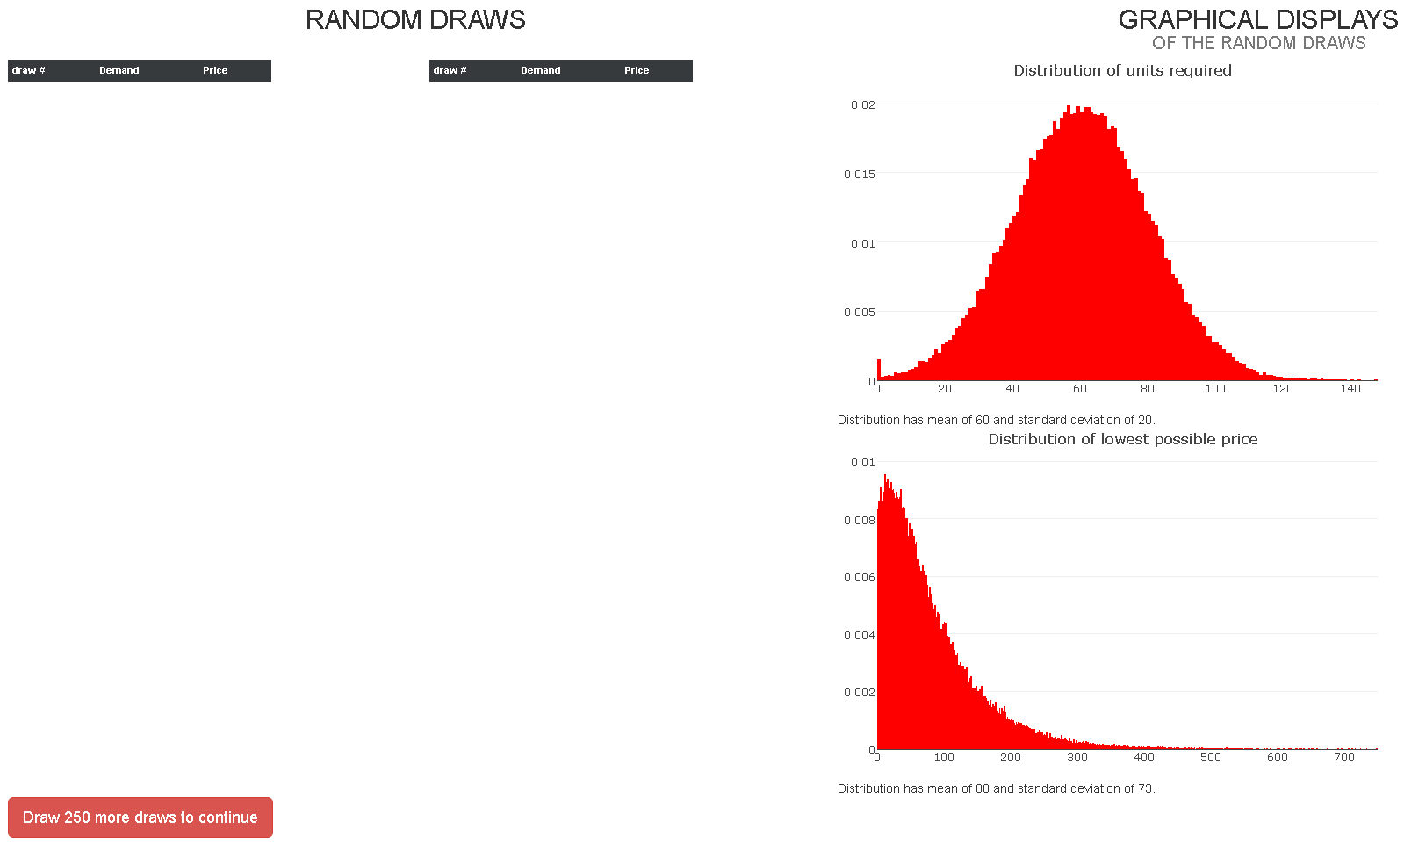

On the right, labeled “GRAPHICAL DISPLAYS”, you see on top “Distribution of UNITS DEMANDED”. The distribution is basically a histogram of the relative frequency of each outcome when the UNITS DEMANDED are drawn 10.000 times at random. You can see that the average is equal to 60.

Below you can see the “Distribution of lowest possible price”. For each value of UNITS DEMANDED, we calculate what is the cost of the last unit if we spread the production of the UNITS DEMANDED as equally as possible over all producers. In other words, if we spread the production of the UNITS DEMANDED as equally as possible over all producers, what is the lowest possible price for which producers could sell their production without making a loss on the sale of the last unit. Notice that this would be the equilibrium price for units if competition were perfect.

To get a better feel for the probability of the outcomes of “UNITS DEMANDED” and “lowest possible price”, you must experiment with this by pressing “Draw”. Each time you press “Draw”, the program generates an outcome for “UNITS DEMANDED” at random from the normal distribution with mean 60 and standard deviation 20. The outcome is also shown in the graph. Figure 19 shows an example. You are obliged to do 60 draws. You may make more draws if you wish, within the time.

Figure 19: Distribution Demand and Production cost for a specific example
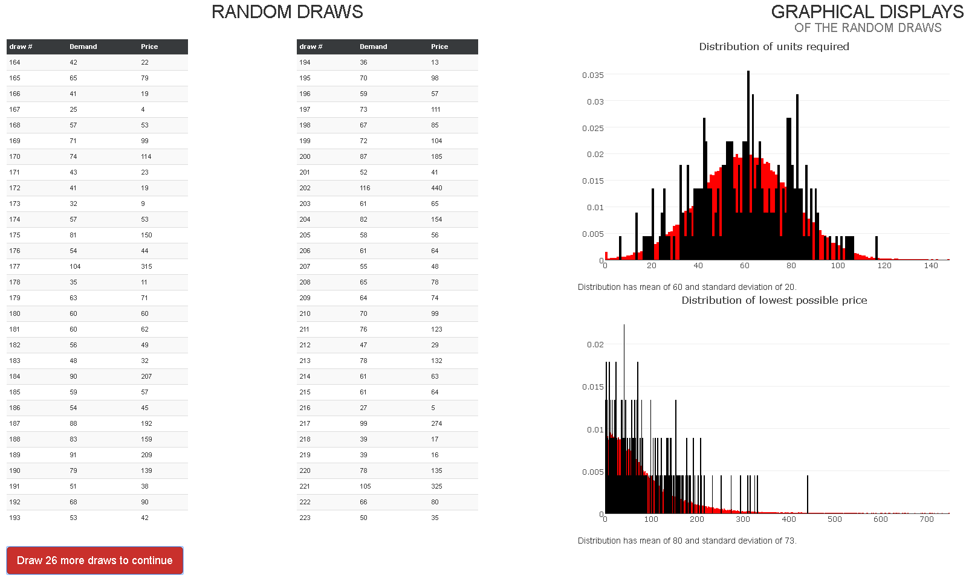
NOT PART OF THE INSTRUCTIONS – PRESENTED TO SUBJECTS ON THE COMPUTER SCREEN

Test questions in the program:

